Software Testing

What is Software Testing
Testing => Verification (Are we building the product the right way?)
+
Validation (Are we building the right product?)

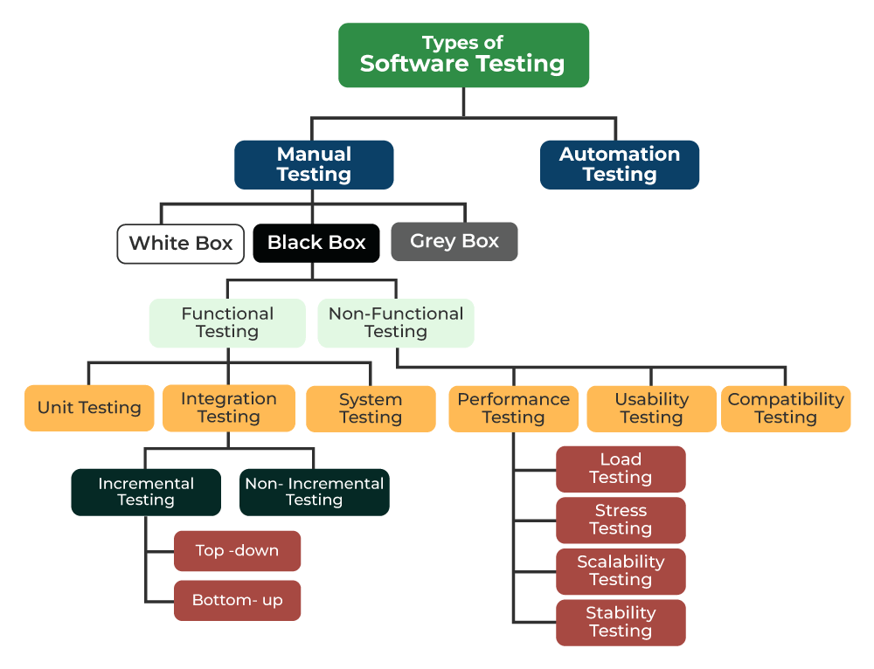
Manual Testing
It is a software testing technique that involves testing the internal structure and working of a software application. The tester has access to the source code and uses this knowledge to design test cases that can verify the correctness of the software at the code level.
In this a tester tests the software by following predefined test cases.
Manual Testing Process

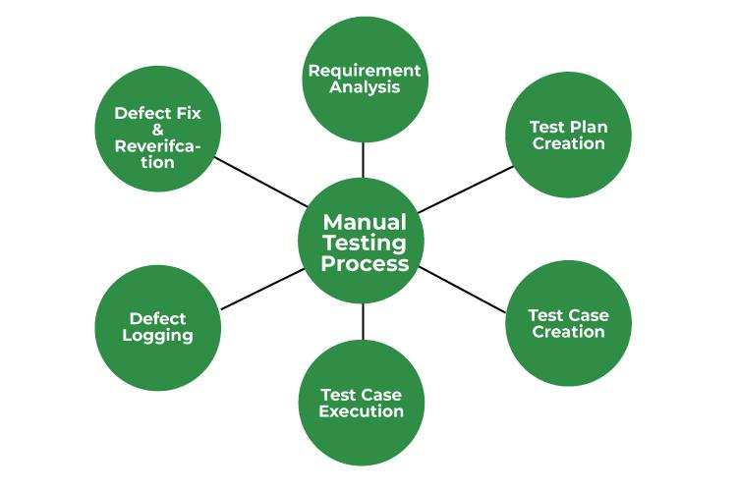

1. Understand Requirements
Know what the software should do by studying functional & non-functional requirements.
2. Create Test Plan
Plan what to test, how to test, resources needed, and timelines.
3. Design Test Cases
Write step-by-step test scenarios with expected results.
4. Set Up Test Environment
Prepare the required software, devices, data, and configurations.
5. Execute Test Cases
Run the tests and compare actual results with expected results.
6. Log Defects
Document bugs with steps, screenshots, expected vs actual results.
7. Track & Verify Defects
Retest after fixes and close or reopen defects.
8. Regression Testing
Recheck existing features to ensure new changes didn’t break anything.
9. Test Closure Report
Summarize testing activities, results, defects, and pending issues.
10. Feedback & Recommendations
Share suggestions to improve product quality and process.

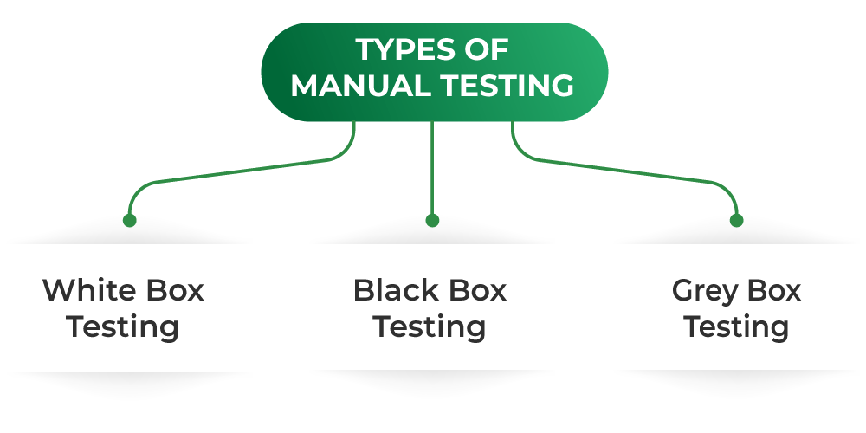
Types :

White Box : It focuses on the internal workings of an application, ensuring that its logic, structure , and flow operate as intended.

Input -------> Processing -----> Test Execution ----> Output

Input – Gathering Essential Doc
Processing – Test Planning(design test cases) and Prioritizing
Test Execution – Running and Redining(Execute tests, Error identification)
Output – Final Report

Disadvantages of White Box Testing:
- Tester must requires deep technical knowledge
- Time-Consuming (writing tests foe all code paths)
- Expensive (Skilled testers + longer execution time)
- Long Execution time
Grey Box : Black Box + White Box
Black Box : It focuses on testing the functionality (user requirements and specification)of the software without any knowlegde of its structure, code, or implemention.
Testers validate the software based on its requirements and specification, ensuring that it behaves as expected for various inputs.

Types :
Functional Testing :
Its is a approach that validates whether a software application’s features work according to the defined business requirements and specifications.
It focuses on what the system does, ensuring outputs for given inputs without inspecting the source code
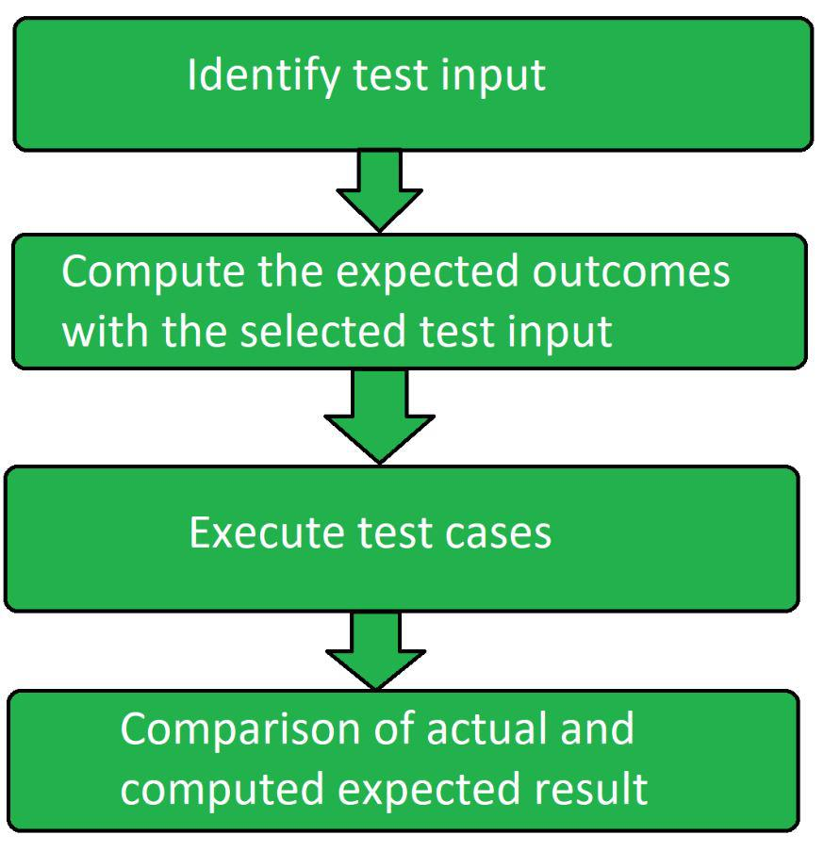
Types :
- Unit Testing :
In this individual units or modules of the application are tested.
It ensures that each module is working correctly.

- Integration Testing :
Combined individual units are tested as a group and expose the faults in the interaction between the integrated units.

- System Testing :
Performed on a completely integrated system to evaluate the compliance of the system.

- Smoke Testing :
The basic functionality or feature of the application is tested as it ensures that the most important function works properly.

Regression Testing :
It is like a Software Quality checkup after any changes are made.
It involves running tests to make sure that everything still works as it should, even after updates or tweaks(improve by making fine adjustments to it) to the code.
Functional requirements define what a system should do, while nonfunctional requirements specify how the system should perform.

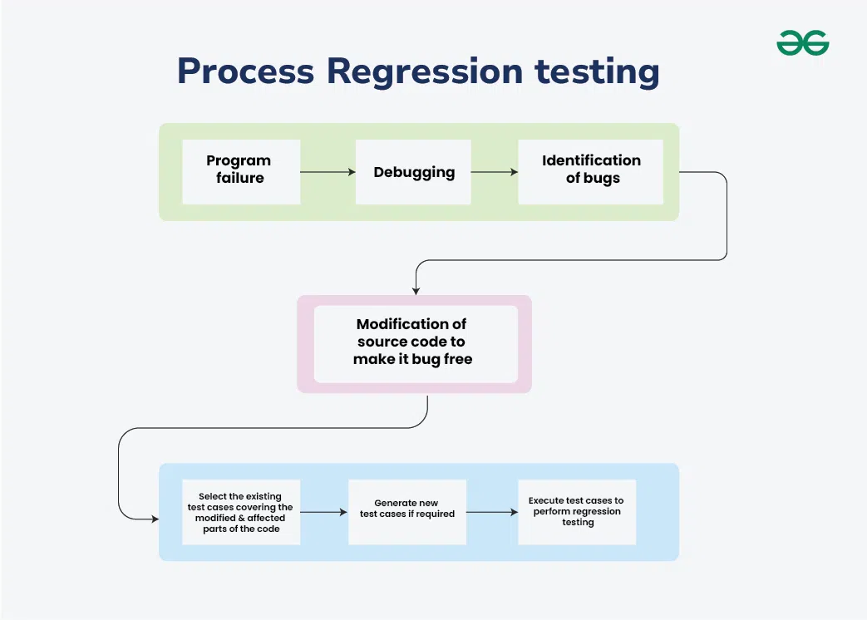

Nonfunctional Testing :
It is performed to verify the non-functional requirements of the application.
It verifies whether the behavior of the system is as per the requirement or not.
It tests all the aspects that are not tested in functional testing.

Example :

1. Black Box Testing Example (No knowledge of internal code)
Scenario: Testing the Place Order feature.
What the tester knows:
Only the UI and requirements — not how the backend/API/database works.
Test Steps
- Select a restaurant
- Add items to the cart
- Apply coupon
- Make payment
- Check order confirmation page
What is tested?
- Is the total amount calculated correctly?
- Is the coupon applied?
- Does the payment success redirect to order confirmation?
- Does an error show for failed payments?
Real-world outcome
Tester checks functionality only, not how the discount logic or payment gateway code works.

2. White Box Testing Example (Full knowledge of code)
Scenario: Testing the discount calculation algorithm in backend code.
What the tester knows:
Complete access to source code, functions, logic, APIs.
Example Code Logic:
if order_amount > 500:
discount = 50
else:
discount = 0

if order_amount > 500:
discount = 50
else:
discount = 0
What the tester performs:
- Unit Testing for all code branches
- Test order_amount = 400 → discount = 0
- Test order_amount = 501 → discount = 50
- Verify code coverage (loops, if/else, boundary values)
- Test API response with internal tools (e.g., Postman)
Real-world outcome
Tester checks how the logic is implemented and ensures every line of code executes properly.

3. Grey Box Testing Example (Partial knowledge of internal system)
Scenario: Testing Order Status Update (Pending → Accepted → Out for Delivery → Delivered)
What the tester knows:
- Database table: orders
- API endpoint: /updateOrderStatus
- Background process triggers status update
Test Steps
- Place an order from the UI
- In database, check if entry is added correctly
- Trigger status update (via API or simulated action)
- Refresh UI → order status should change
- Verify DB values are updated correctly
What is tested?
- UI flow (Black Box part)
- Database, APIs, internal events (White Box part)
Real-world outcome
Tester uses UI + technical knowledge (DB/API) to find deeper issues that pure black box testing cannot catch.

Disadvantages of Black Box testing :
- Limited Test Coverage (Cannot test internal paths, code logic, or structure)
- Not efficient for many possible inputs/outputs
- Test cases design can be difficult (incomplete or ambiguous requirements)
- Lack of insight into code (Debugging is slower)

Principles of Software testing - Software Testing

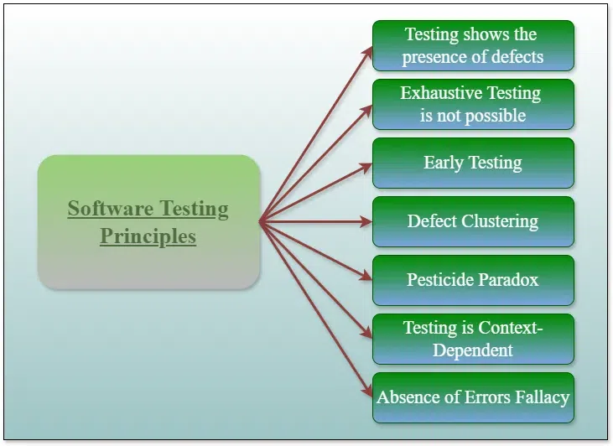

Seven Principles of Software Testing
1. Testing Shows Presence of Defects
Testing finds bugs, but can never prove that the software is 100% bug-free.
2. Exhaustive Testing is Not Possible
You cannot test every input/output; only selected test cases are tested.
3. Early Testing
Start testing early in SDLC to find defects sooner and reduce cost.
4. Defect Clustering
Most defects are usually found in a small number of modules.
The Pareto Principle for software testing states that 80% of software defects come from 20% of modules.
5. Pesticide Paradox
Repeating the same tests won't find new bugs; test cases must be updated regularly.
6. Testing is Context-Dependent
Different applications require different testing approaches.
7. Absence of Errors Fallacy
Even if the software has no bugs, it’s useless if it doesn’t meet user requirements.

Software Testing Life Cycle (STLC)
The Software Testing Life Cycle (STLC) is a process that verifies whether the Software Quality meets the expectations or not.
STLC is an important process that provides a simple approach to testing through the step-by-step process.

Phases of STLC

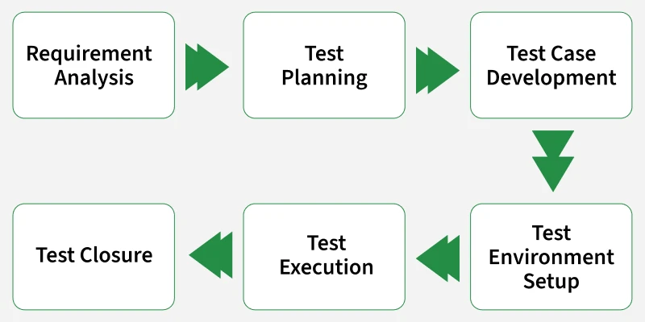

STLC Phases :
1. Requirement Analysis
Testers study the requirements to understand what needs to be tested.
They identify gaps, unclear points, and potential risks.
2. Test Planning
A detailed test strategy is created, defining scope, resources, tools, and timelines.
It acts as the roadmap for the entire testing process.
3. Test Case Development
Testers write test cases and prepare test data based on requirements.
All test cases are reviewed and linked to requirements using RTM.
4. Test Environment Setup
The environment (software, devices, databases) required for testing is prepared.
Testers validate that setup is working before execution.
5. Test Execution
Testers run test cases, compare results, and log defects.
Retesting and regression testing are performed as needed.
6. Test Closure
A test summary report is created and all artifacts are archived.
Team evaluates the process, closes defects, and shares lessons learned.

Levels of Software Testing
The software testing is the one of important processes followed in the SDLC to ensure that the software is delivered as per quality.
This means that maximum bugs should be detected, and resolved and software should work seamlessly with customers.
In order to achieve this, it goes through various levels of testing.

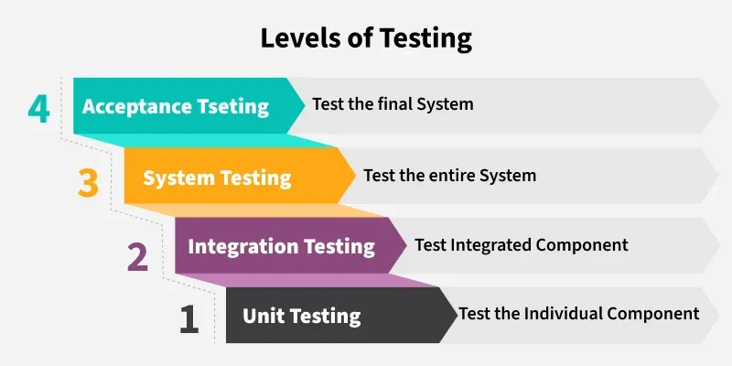

1. Unit Testing
Testing individual functions or components to ensure they work correctly in isolation.
Helps catch bugs early and ensures each small part of the software behaves as expected.

2. Integration Testing
Checks how different modules interact and work together.
Ensures data flow and communication between components is smooth and error-free.

3. System Testing
Testing the entire application as a whole in a real-world-like environment.
Validates both functional and non-functional requirements to ensure the system works end-to-end.

4. Acceptance Testing (UAT)
Performed by end-users or clients to verify the software meets business needs.
Final validation before release, ensuring the system is ready for production.

Test Maturity Model (TMM) And TMM Integration(TMMI)
TMM is a framework for assessing the software testing process to improve it.
Test Maturity Model Integration
Test Maturity Model Integration (TMMI) which has replaced the Test Maturity Model. TMMI has a five-level model that provides a framework to measure the maturity of the testing processes.
The purpose of a Test maturity model is to find the maturity and provide targets for enhancing the overall software testing process.

Five Level of TMMi

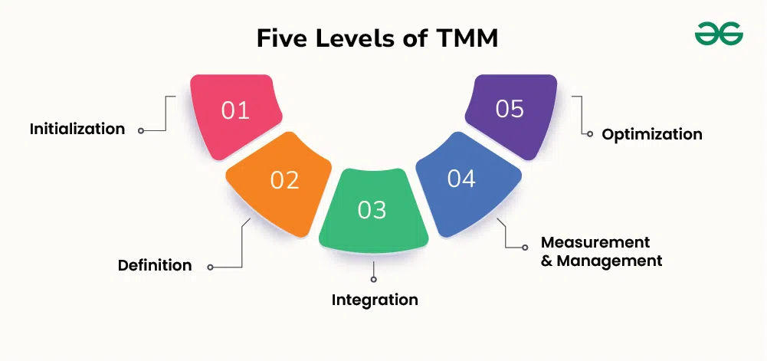

Level 1: Initialization
Testing is unstructured and mostly ad-hoc with no defined process.
Software can run, but no formal quality checks or documentation exist.

Level 2: Definition
Basic testing processes are defined based on requirements.
Test plans, strategies, and test cases are created and executed formally.

Level 3: Integration
Testing becomes an independent phase integrated into the SDLC.
Focus shifts to risk-based testing and structured procedures.

Level 4: Measurement & Management
Testing activities are measured, reviewed, and fully integrated into the development lifecycle.
Reviews, unit testing, integration testing, and code inspections are standard practice.

Level 5: Optimization
Testing processes are optimized and continuously improved.
Defect prevention, reuse, and advanced testing tools are used to avoid future issues.

